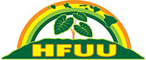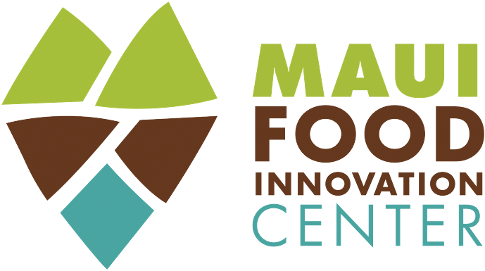

Announcing Hāna Ag Roadshow Webinar, August 8, 2020 11:00 AM

A FREE agricultural resource webinar, called the Hāna Ag Roadshow, is happening on Saturday, August 8 at 11am. The goal of this webinar is to facilitate and support the expansion of our local food resource base in East Maui, as a model and means of connecting production in our community out to the greater market arenas of Maui, the State of Hawai‘i and the world across the Pacific.

This program is being organized in support of East Maui food entrepreneurs through a combined effort between the University of Hawai‘i Maui College (UHMC) - Maui Food Innovation Center (MFIC), UH Manoa College of Tropical Agriculture and Human Resources (CTAHR), Maui Office of Economic Development (OED), Maui Department of Health, Hana Business Council members, Hana Farmers Union United (HFUU) – Hana Chapter members, Hana Farmers Market, Ma Ka Hana Ka ‘Ike, Hana School, UHMC Hana Education Center, and the Hana County Council Office.

The webinar will include a welcome by UHMC Chancellor Lui Hokoana & East Maui representatives, and provide an overview of the Maui Food Innovation Center and new Maui College food production facility. We will introduce the Hāna Ag Roadshow team and share the innovative product submissions from the related Hāna Food Launch Tasting Event to the Hāna community, followed by a moderated Q&A session.

The Hāna Roadshow team of educators and agricultural resource experts from these organizations will be giving FREE assessments for East Maui food entrepreneurs in advance of the webinar, providing a Farm/Product report for up to 10 applicants, and extend an invitation to a Hāna Food Launch Tasting Event. The team will choose the ‘top 3 submissions’ from the applicant pool to receive educational or certification support, and an invitation to participate within the August 8th webinar event.

The Product Report given to Hāna Food Launch Tasting Event applicants will include guidance and direction from the team, and provide recommendations for educational opportunities, necessary certifications around safe food handling (DOH Green Placard), business and tax guidelines, distribution channel utilization support, and product and business scalability insight.

For information about this event please contact Gary Albitz at the University of Hawai‘i Maui Food Innovation Center at (808) 281-9672, or via email albitzg@hawaii.edu.

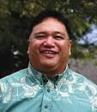

UHMC Chancellor Lui Hokoana

